‘Hard’ and ‘soft’ systems
- Systems ideas have been applied to various problematic health issues including diabetes and obesity. Systems is relatively novel within public health and not without challenges.
- While all systems approaches are committed to understanding problems holistically, commitment to holism (i.e., whole greater than sum of the parts), the use and conceptualization of specific systems concepts varies depending on approach. There is a range of soft, hard, and critical traditions including general systems theory, system dynamics, cybernetics, complex adaptive systems, soft systems methodology, and critical systems thinking. For example, the concept ‘system’ provides illustration of differences between hard and soft approaches. From the hard perspective, a ‘system’ is an entity that exists in the real world such as a health system. Much of the literature on quality improvement in health adopts this perspective. In contrast, the soft approach regards a ‘system’ as a way of organising thinking about problematic situations.

Soft Systems Methodology
- Soft Systems Methodology (SSM) was developed by Peter Checkland and colleagues over a 30 year programme of action research (e.g., Checkland, 1981; Checkland and Scholes, 1990; Checkland and Poulter, 2006). SSM has been extensively used in areas such as health services research (e.g., Vandenbroeck et al., 2014), information systems development (Winter et al., 1995) and evaluation (e.g., Foote et al., 2009).
- For an accessible introduction to SSM principles, methods and practices see Checkland and Poulter’s (2006) Learning in action: a short definitive account of soft systems methodology and its use for practitioners, teachers and students.
- SSM is an approach to addressing ill-defined problems. Such problematic situations are ‘messes’. That is, complex sets of interacting issues that are resistant to definition and solution. Messes cannot be solved but need to be managed on an ongoing basis.
- SSM is used to:
  - Gain insights into problematic situations
  - Set intervention purposes and develop strategic objectives
  - Develop shared understanding about issues and buy-in to actions
- Unlike ‘hard’ systems approaches, SSM is agnostic about whether systems exist in the real world. Instead, SSM draws on systems concepts to create a process of learning which examines the different viewpoints held about a problematic situation and encourages a shared understanding about what actions are desirable and feasible. That is, likely to led to improvement.
- A soft systems study is undertaken in collaboration with stakeholders and structured around four principles:
- Finding out about the problematic situation;
- Developing models of purposeful activity to direct inquiry about the problematic situation;
- Comparing (2) with (1) to develop a collective understanding about the problematic situation and determine what actions might constitute an improvement; and
- Structured dialogue about desirable and feasible changes.
- Finding out about the problematic situation
  - Information about the problematic situation is collected using a variety methods including interviews, hui, documentary analysis, observations and surveys. The complexity of issues is visually represented as a rich picture highlighting key inter-relationships and possible boundaries (see Figure 1 for an example). Analyses of the intervention including the context and power relations also deepen an appreciation of what change is desirable and feasible.

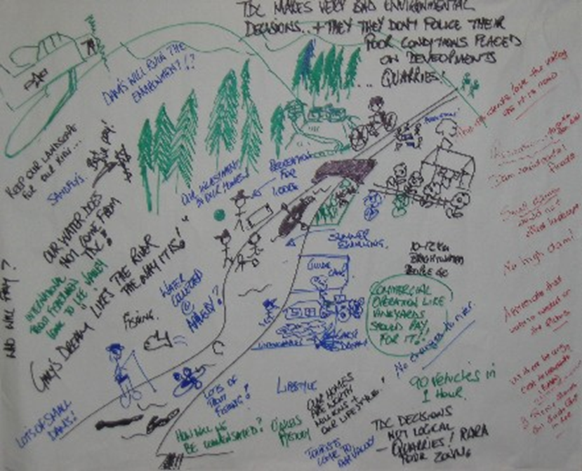
Figure 1: A rich picture of water use (Winstanley et al., 2016)

- Developing models of purposeful activity
  - In SSM, problematic situations are explored using models of purposeful activity.
  - SSM assumes that action to understand or improve a problematic situation is purposeful. That is, intentional.
  - These models represent ‘relevant systems’ that might improve the problematic situation.
  - Models of purposeful activity can be developed using PQR formula and sharpened up using CATWOE method.
    - The PQR formula expresses a ‘relevant system’ in terms of a “way to do [P], by [Q] in order to achieve [Q]”.
    - CATWOE stands for C(lient), A(ctor), T(ransformation), W(orldview), O(wner) and E(nvironment).
      - The T(ransformation) and W(orldview) set out the improvement and the perspective from which the improvement is seen as desirable The T(ransformation) is expressed in terms of moving from an undesired state to a desired state (“undesired statedesired state”)
      - The A(ctors) define who will carry out the T(ransformation).
      - The C(lient) defines who benefits (or is disadvantaged) from the T(ransformation), and the O(wner) determines who can stop the T(ransformation) from happening
      - The E(nvironment) details what must be taken as a given when undertaking the T(ransformation)
    - See Table 1 for an example.
  - Multiple models of purposeful activity are created in order to prevent premature narrowing of perspectives on improvement.
  - Models of purposeful activity are given expression as conceptual models which set out what activities have to logically occur in what order to give effect to the T(ransformation). Activities are brainstormed, expressed with verbs up-front, and placed in relationship to one another (see Figure 2 for an example).

Table 1: Developing a community environmental action plan (Adapted from Foote et al., 2009)
PQR: To develop a [community environmental action plan] by [pooling together the knowledge of stakeholders and Māori] in order to [achieve coordinated action]
T(ransformation) | Community fail to understand the state of the environment Community understand the environmental priorities
C(lient) | Fish and Game, Māori, community members, conservationists, recreationalists, farmers, individual landowners, environment
A(ctors) | Community leaders, Regional Council staff (e.g. engineers, scientists), government agencies, interest groups, business, Māori, individual landowners
W(orldview) | The role of the regional council is to support community (be on tap, not on top)
O(wner) | Powerful (articulate/‘loud’) actors with a negative view of the community action plan, government agencies, council elected representatives
E(nvironment) | Funding, time, information or understanding, willingness of participants to resolve issues

Figure 2: Conceptual model of creating a community environmental plan (Foote et al., 2009)
- Comparing models of purposeful activity with the problematic situation
  - The models of purposeful activity provide a structure way to inquire about the problematic situation.
  - Activities set out in the conceptual model are checked against the ‘rich picture’ to determine:
    - Does the activity occur in practice?
    - If not, should the activity be done?
    - If yes, how well is the activity done? How might the activity be improved?
- Structured dialogue about desirable and feasible changes
  - The process of systematically comparing the models of purposeful activity with the problematic situation will surface a number of actions that may lead to improvement. SSM encourages accommodation rather than consensus. That is, actions that participants can live with.
  - Actions are then implemented and evaluated.

References
Checkland, P. (1981). Systems thinking, systems practice. Chichester: Wiley.
Checkland, P. & Scholes, J. (1990). Soft systems methodology in action. Chichester: Wiley.
Checkland, P., & Poulter, J. (2006). Learning for action: a short definitive account of soft systems methodology and its use, for practitioners, teachers and students. Chichester: Wiley.
Foote, J., Ahuriri-Driscoll, A., & Hepi, M. (2009, July). Systemic evaluation of community environmental management programmes. In Proceedings of the 53rd Annual Meeting of the International Systems Science Society, Brisbane, Australia.
Vandenbroeck, P., Dechenne, R., Becher, K., Eyssen, M., & Van den Heede, K. (2014). Recommendations for the organization of mental health services for children and adolescents in Belgium: use of the soft systems methodology. Health Policy, 114(2-3), 263-268.
Winter, M., Brown, D. H., & Checkland, P. B. (1995). A role for soft systems methodology in information systems development. European Journal of Information Systems, 4(3), 130-142.
Winstanley, A., Ahuriri-Driscoll, A., Hepi, M., Baker, V., & Foote, J. (2016). Understanding the impact of democratic logics on participatory resource decision-making in New Zealand. Local Environment, 21(10), 1171-1184.

Template

Creating a rich picture (Walton and Foote, 2016)
- All perspectives are valid
- No judgements on the quality of drawing
- Use pictures fist, and words second to clarify (if needed)
- One pen, one ‘artist’ at a time.
- Ask questions. Discuss. Engage.

Developing purposeful activity systems
- Review the ‘rich picture’ and identify potential improvements
Potential improvements:
- ___________________________________________________________________________
- ___________________________________________________________________________
- ___________________________________________________________________________
- ___________________________________________________________________________
- ___________________________________________________________________________

- Use PQR formulae or CATWOE method (or both) to clearly articulate what is meant by EACH potential improvement.
- If PQR:
  - Unpack the improvement in terms of “do [P], by [Q] in order to [R]”
  - [P] is the change that results in an improvement, [Q] is the means by which the change is brought about, and [R] is the rationale (or ‘pot of gold’) for the improvement
The change [P]: _____________________________________________________________________
The means [Q]: _____________________________________________________________________
The reason [R]: _____________________________________________________________________
- If CATWOE
  - Start by unpacking the improvement in terms of the T(ransformation) and the W(orldview)
  - Express the T(ransformation) in terms of undesired state desired state.
  - Brainstorm possible W(orldviews). That is, any assumptions that makes the T(ransformation) meaningful.
  - Brainstorm remaining elements including C(lients), A(ctors), O(wner) and E(nvironment)
T(ransformation): ___________________________________________________________________
W(orldview): _______________________________________________________________________
C(lients): __________________________________________________________________________
A(ctors): __________________________________________________________________________
O(wner): __________________________________________________________________________
E(nvironment): _____________________________________________________________________

- Create conceptual models for each PQR and/or CATWOE
  - Brainstorm 7 ± 2 logical activities that have to take place to bring about the T(ransformation)
  - Remove any duplicates, identify activities which can happen independently of others and identify those which dependent are other activities
  - Place activities in sequence and add any significant relationships
  - Review conceptual model for clarity
  - Include monitoring and evaluation activity to complete the conceptual model

Activities:
- ___________________________________________________________________________
- ___________________________________________________________________________
- ___________________________________________________________________________
- ___________________________________________________________________________
- ___________________________________________________________________________
- ___________________________________________________________________________
- ___________________________________________________________________________
- ___________________________________________________________________________
- ___________________________________________________________________________

Independent activities:
- ___________________________________________________________________________
- ___________________________________________________________________________
- ___________________________________________________________________________
- ___________________________________________________________________________

Dependent activities
- ___________________________________________________________________________
- ___________________________________________________________________________
- ___________________________________________________________________________
- ___________________________________________________________________________
- ___________________________________________________________________________
- ___________________________________________________________________________
- ___________________________________________________________________________

Comparing models of purposeful activity with the problematic situation
- Review rich picture and conceptual models
- Systematically compare the activities in the conceptual models with what is known about the problematic situation
  - Does the activity occur in practice?
  - If not, should the activity be done?
  - If yes, how well is the activity done? How might the activity be improved?
- Brainstorm and record possible actions
Activity | In practice? | Evaluation | Possible actions
1
2
3
4
5
6 etc

Structured dialogue about desirable and feasible changes
- Review possible actions noted above
- Debate: to what extent are the actions desired and feasible?

